Nama: Mohammad Daffa Raihansyah
NIM: 266151031
Kelas: 1B

Task 1:
create table anggota (
-> id_anggota varchar(10) primary key,
-> nama_lengkap varchar(100) not null,
-> email_instansi varchar(100) unique not null,
-> poin_pelanggaran int,
-> constraint chk_pelanggaran check (poin_pelanggaran <= 100 and poin_pelanggaran >= 0)
-> );
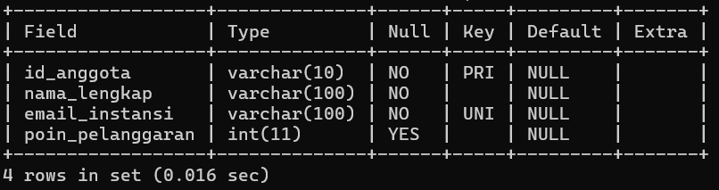

create table transaksi_sewa (
-> id_sewa int auto_increment primary key,
-> id_anggota varchar(10) not null,
-> nama_alat varchar(100) not null,
-> biaya_sewa decimal(10,2),
-> tanggal_pinjam date,
-> status_pinjam varchar(20) default 'dipinjam',
-> foreign key (id_anggota) references anggota(id_anggota)
-> on delete restrict on update cascade,
-> constraint chk_biaya_sewa check (biaya_sewa <= 15000.00)
-> );
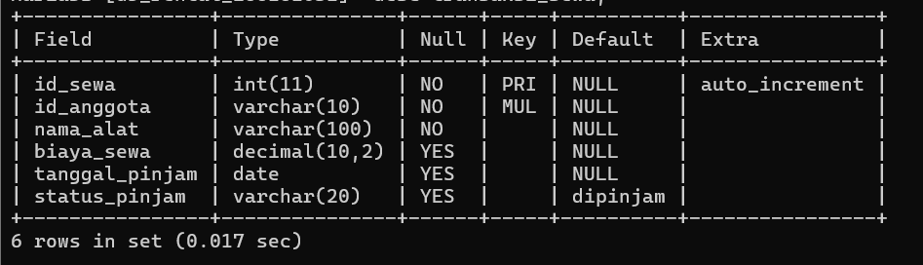

Task 2:
insert into anggota
-> values
-> ('142501','Arif Cahyo Nugroho','arifcahyo2007@gmail.com',0),
-> ('142402','Andrian Maulana','andrianamaulana14@gmail.com',10),
-> ('142603','Raisya Abdillah','ecakabdul09@gmail.com',30);
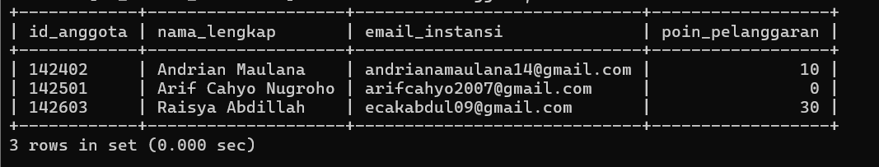

insert into transaksi_sewa
-> values
-> ('2601','142402','Wuthering Heights',9000.00,'2026-05-21','dipinjam'),
-> ('2602','142402','Kamera Professional',1200.00,'2026-04-18','kembali'),
-> ('2603','142501','Buku Don Quixote De LaMancha',2000.00,'2025-09-30','kembali'),
-> ('2604','142603','Mikrotik Router dan Kabel UTP',15000.00,'2024-05-06','kembali');
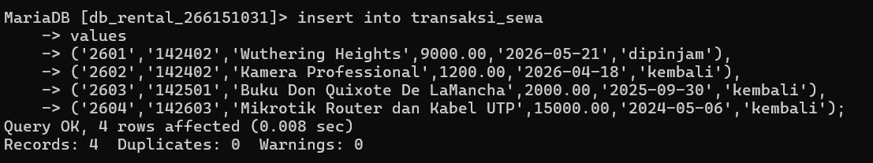

update transaksi_sewa
-> set status_pinjam = 'kembali'
-> where status_pinjam <= 100000.00;
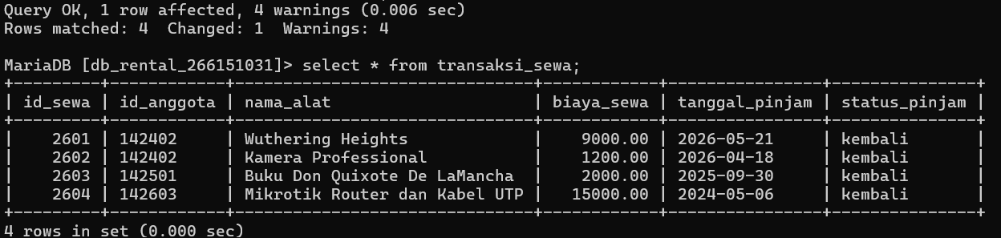

create table arsip_transaksi_sewa like transaksi_sewa;

insert into arsip_transaksi_sewa
-> select * from transaksi_sewa
-> where tanggal_pinjam < '2026-01-01';
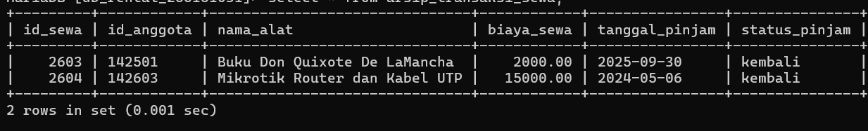

delete from transaksi_sewa
-> where tanggal_pinjam < '2026-01-01';
Task 3
select * from anggota
-> where poin_pelanggaran <= 10 and email_instansi like '%@gmail.com';


